HDFS- What and Why:

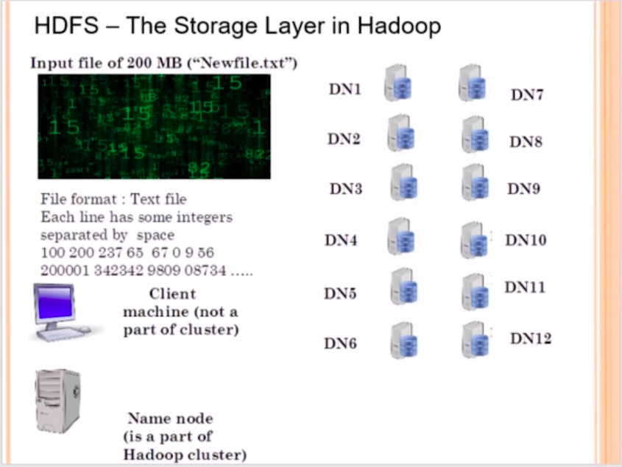

Imagine you have a 1 GB or 2 GB file, and if you want to save that file in your hard-drive, that file will be saved as a single file or a single block. However, In Hadoop, It’s different, Assume that, We have a 200 MB file called as New_file.txt. Since, Hadoop is a distributed File System, which means the 200 MB file will be broken down into smaller blocks of data and it will be distributed across the Data Nodes in the cluster. The file of 200 Mbs will not be save as a single file in one system.

Now as a Analyst, If we are going to submit/push a file into the Hadoop cluster by communicating with the name node. When we install hadoop, there is something called as input file size, which is configured as a system wide parameter by the hadoop administrator. In this case, the input split size will set to be 64 Mbs and for certain reasons it is kept as 64 Mbs and Not less than 64 Mbs. However, at the will of the hadoop administrator, the 64 MB can be increased in multiple of 64, means, you can have split size of 64 MB, 128 MB, 256 MB and so on, but the minimum is recommended to be 64 MB.

Since the input file size is 200 MB and 64 MB is the split size which is global across the Hadoop Cluster set by the Hadoop admin, The input file will be divided into 4 blocks. (N1, N2, N3, N4) and this work is done with the help of the Name Node. And the client machine is the one you are using which is trying to communicate with the name node.

Now, the 4 blocks of data will be stored inside the Data Node, and this job will be done by the Hadoop Distributed File System.
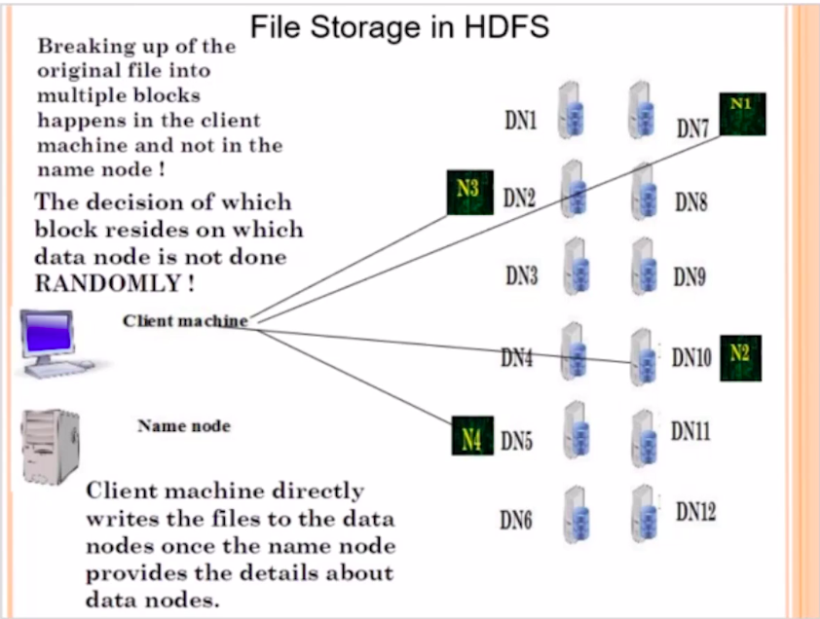

NOTE: The 4 File blocks is not going to be arranged randomly in the Data nodes. There is an algorithm running behind which decides which block has to actually go and sit on which particular data node. The Name node is going to remember where exactly the blocks corresponding to a particular file which we have pushed in the cluster are residing. How big is the block size? What are the host names of the data nodes in which the blocks are present. All these information is going to be present in the form of File Table (FS Image). Which is going to be maintained in the name node.

The name of the File Table is called as (FS Image) . FS stands for File System Image. Assume the FS page as the contents/index page of a book. Similarly, FS Image is the table which remembers, where the blocks of the original file are actually going to be stored.

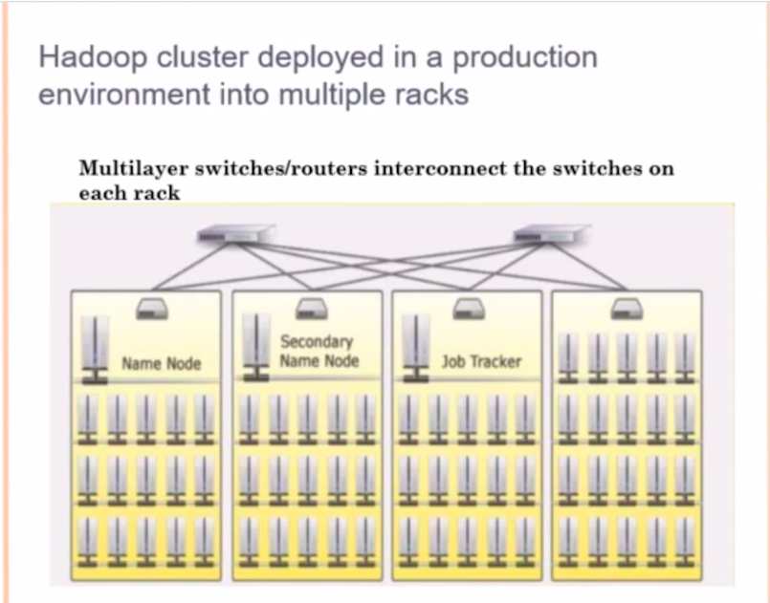

Notice that the Name Node, Secondary Name Node and the Job Tracker are kept in a different rack,
because, in case a single rack failed then all the servers will go down at once. To avoid this, it’s a good practice to have different servers across different racks. And the typical industry standard is to have 20-30 data nodes per rack.

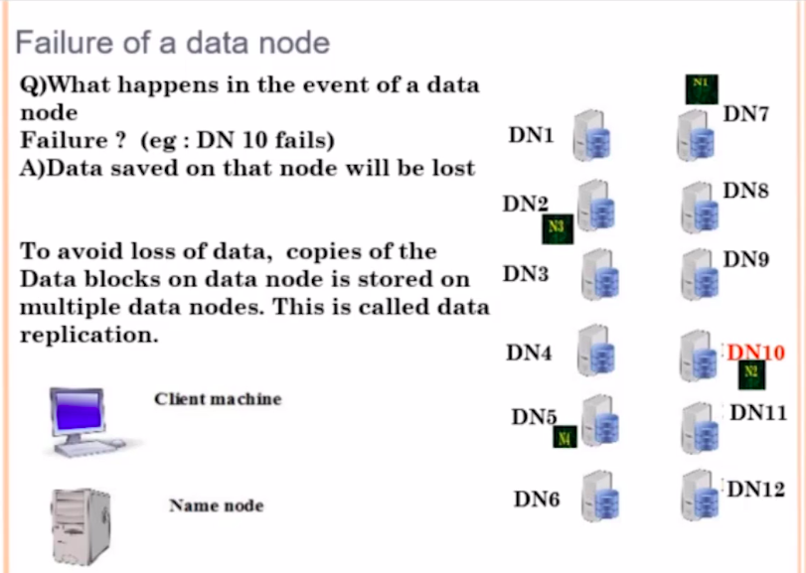

What if the Data Node (DN10) Fails, It means that our file is know corrupted. And here we are talking about big data file. Even if one small block of data is corrupted, the whole data is lost. So, to prevent this kind of a failure, we replicate these blocks, so by default every block in the HDFS is replicated 3 times. So, if your original file is occupying 1 PB of data, than in Hadoop cluster it occupies 3 PB of data. And we cannot change it, because fail over and recovery is more important than occupying the hard-disk space.

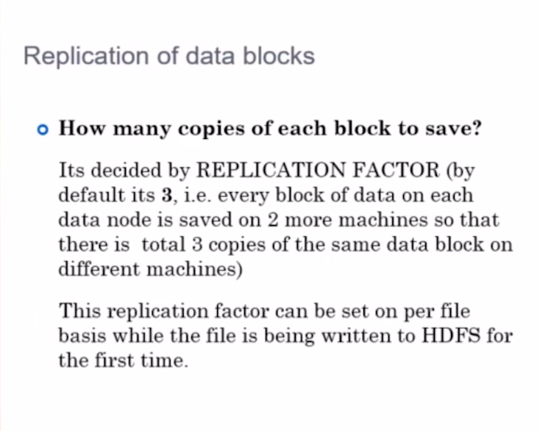
This is called as the replication factor, Which is configured across the system. System wide
replication factor is said to be 3. Now, you can ask a question like, what if we have a replication factor of two, yes you can have it, but not recommended. You can also have a replication factor of greater than 3, but it will occupy too much of space. So, the optimal size is 3. Which is a system wide parameter. Which the system admin will configure while installing hadoop. You as a developer don’t have to worry about these things. You just have to know that every block of data in HDFS is going to be replicated 3 times.

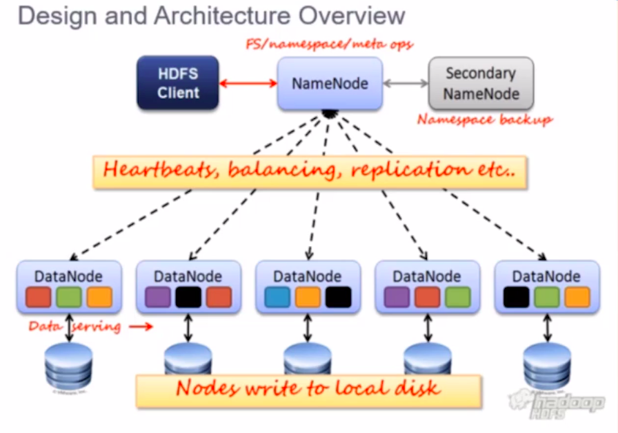

Remember, every data node is sending a Heart Beat signal to the name node. In case, if the data node fails to send a heartbeat signal withing 3 seconds, the Name node assume that the data node is down. So now the replication is 2 copies, the Name node will then raise an system wide alarm to copy the blocks from the neighboring node, to restore the replication factor of 3 across the cluster for the blocks.

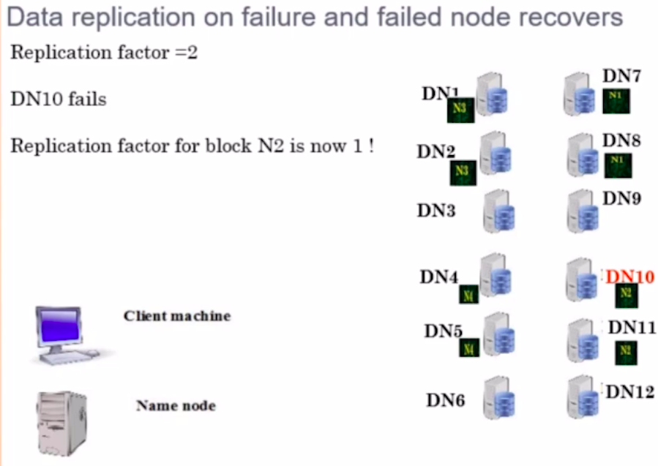

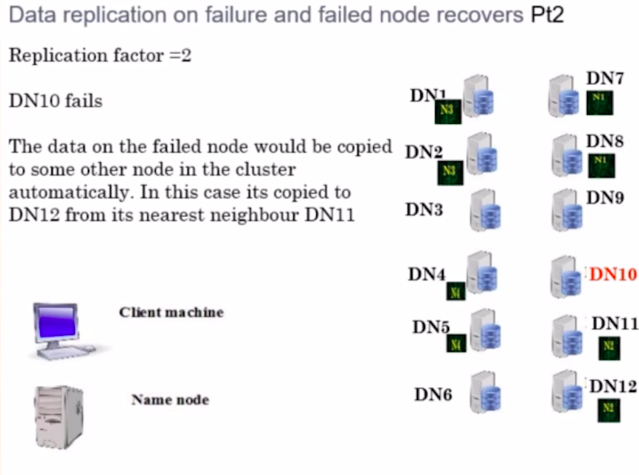

This actually solve the problem of automatic failover and automatic recovery.

Now what if the Data Node (DN 10) is up and running again.
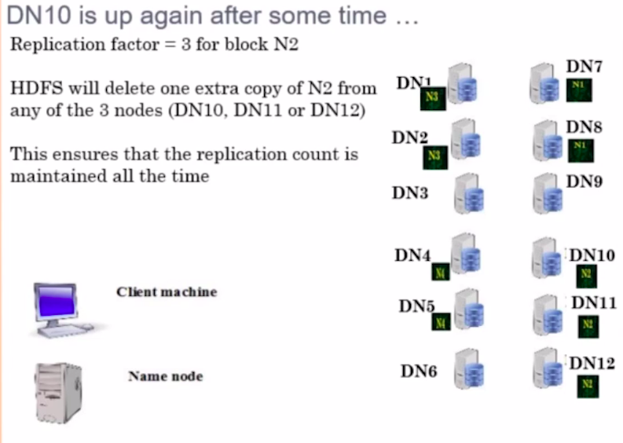

Now, the replication factor is actually 2, but for N2 , there are 3 Blocks, so the Name Node will delete a random N2 block from the cluster. To make sure that every block is replicated 2 times in the cluster. Because 2 is the replication factor for us. This is automatic in the HDFS, there is no need of manual intervention.

Replica Placement Strategy

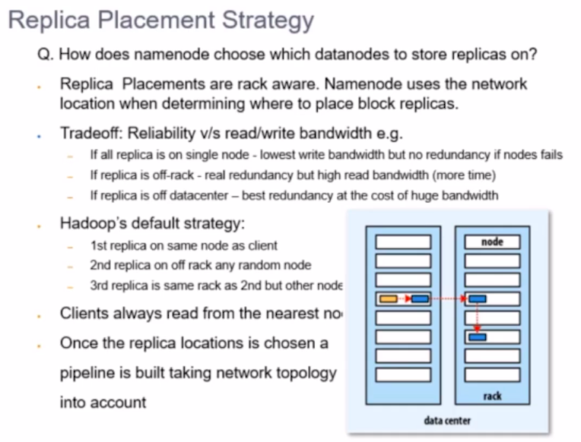
Assume that, the yellow color block is the original data, a copy of the data is kept in the data node. Imagine that, only blue block are present in the data center as data blocks. Now, since 3 copies of every data block have to be maintained across the cluster, It’s a common sense things for you to copy 3 blocks of data into 3 different Racks, But that is not the case, it isn’t done usually.

Actually, one block is kept in Rack 1, and two other replica of the same block is kept in the adjacent node. In the diagram, it’s Rack 2. Why is this done? This is done because, copying from within the same rack is less time consuming as compared to copying a data node across the Racks.

You might ask, what happens if the data node in Rack 1 is corrupted or fails, In that case, yes you still have to a replica of data block from Rack 2 to Rack 1, hence Replica of data blocks are kept in the adjacent Racks.

What if One data node from Rack 2 fails,which contains the replica of the data block. It will be very fast and easier to copy the data block from one data node to another data node within the Rack 2.

That is the reason why, One block is kept in one data node in one rack, and two other blocks are actually kept on two different data nodes in the adjacent rack but in a single rack rather that having a new rack for the third replica. This is the block Placement Strategy what HDFS actually adopts.

Remember, we are not dealing with 64 MB blocks, Recall that each data node will have a hard disk of something close to 50 to 100 terabytes, And if one data node fails, it means, the entire hard drive becomes inaccessible. So, the other data node will have to copy the entire hard-drive contents of one data node, even a small millisecond delay in cross rack hops will have a huge impact overall while transferring data from one rack to another. Again, it’s a big data platform.

Name Node and Secondary Name Node in Hadoop 1.0

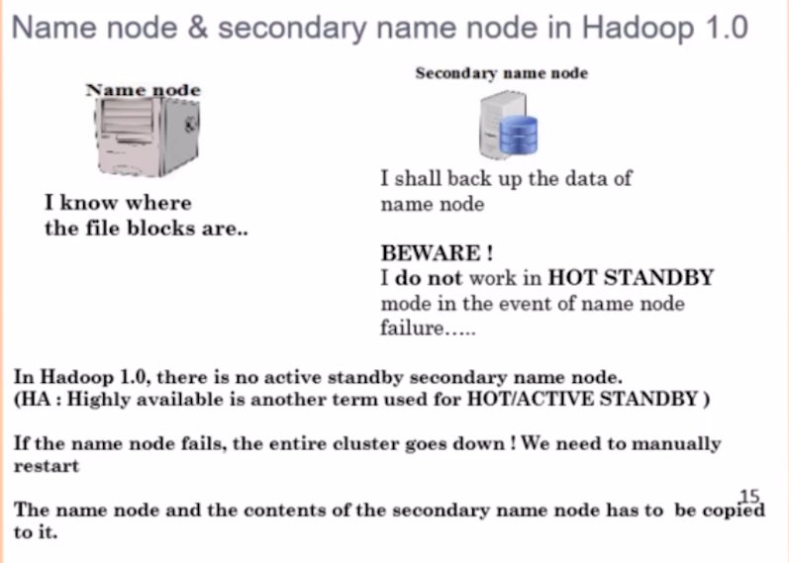

Let’s understand the role of Secondary Name Node. As we know that the name node is going to maintain the centralized file table called as File System Image, It’s like the contents/index in a textbook.

The File Table in the Name Node will tell you, where exactly the blocks corresponding to that file is located in the data nodes. So, the File System Image is going to be maintained by the Secondary Name Node.

So In the event of a name node failure, the entire cluster will be inaccessible, if your name node fails, It doesn't mean that the data in the data nodes will be lost, the Data will be present but there will be no way to know, in which node it is present. Assume, What will happen if the index page is gone from a book.

To Prevent from scanning the entire cluster again to Create the File System Image, We have a secondary Name Node and the System/Hadoop Admin will intervene and will restore the name node and copy the File System Image back to the Name node and the cluster will be reusable again. However the problem is fixed in hadoop version 2.0, So the Name Node will have a Hot Stand by Name node, So when the Name node fails, automatically the Hot Stand by Name node will be up and running, So the cluster services will not get affected, even in Hadoop 2.0 we will have the secondary Name Node. Only in Hadoop 1.0 we don’t have a Hot Stand By Name Node, So If it’s fails, cluster become inaccessible. But data is not lost from the hard drive.

When to/not to use HDFS?

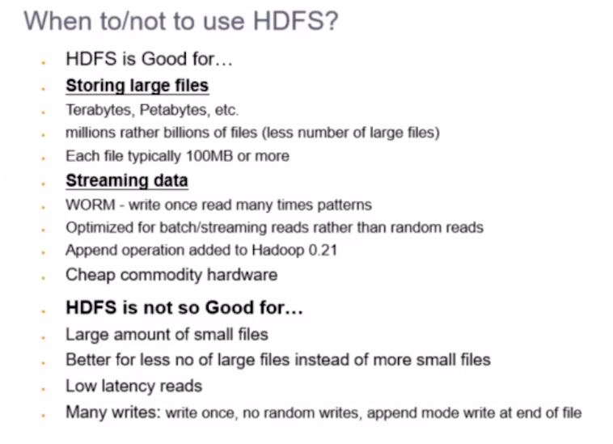

HDFS is excellent when we have to store large amount of BIG Files.

It’s very bad for storing large amount of small files. If you have too many small files, It will occupy too much of space or too many Indexes in File System Image. So if you have too many small files, merge them into a single file and then store them into the HDFS, but this approach might not make sense for most of the use cases.

So, HDFS is useful for storing large volume of Huge Files, because the files are going to be divided into smaller blocks and they will reside into multiple data nodes.

The key feature of HDFS is, It doesn't allow you edit the data once you store them in the data nodes. HDFS is write only File System and also Write Only Once. You Cannot write again and again. Mean, you cannot override the files, you cannot edit the files. So it’s Write Once and Read Many times File System.

However in Hadoop 2.0 appending is allowed. You can append to an existing file but you cannot edit the files. The reason is: In parallel programming, editing a file leads to race condition and synchronization Issues, Which hadoop has completely avoided by keeping the data immutable.

